CAPSTONE PROJECT REPORT
On
Use of Hardware Descriptive Language for allocating appropriate IC to the student in lab or industry
Submitted in partial fulfillment of the requirement for the award of the degree of

Bachelors of Technology In
Electronics & Communication Engineering


Under the Guidance Dr.Amit Sachdeva
Associate Professor, School Electronics and Electrical Engineering (Lovely Professional University, Punjab)
Submitted by:
Rahul Yadav
11808029

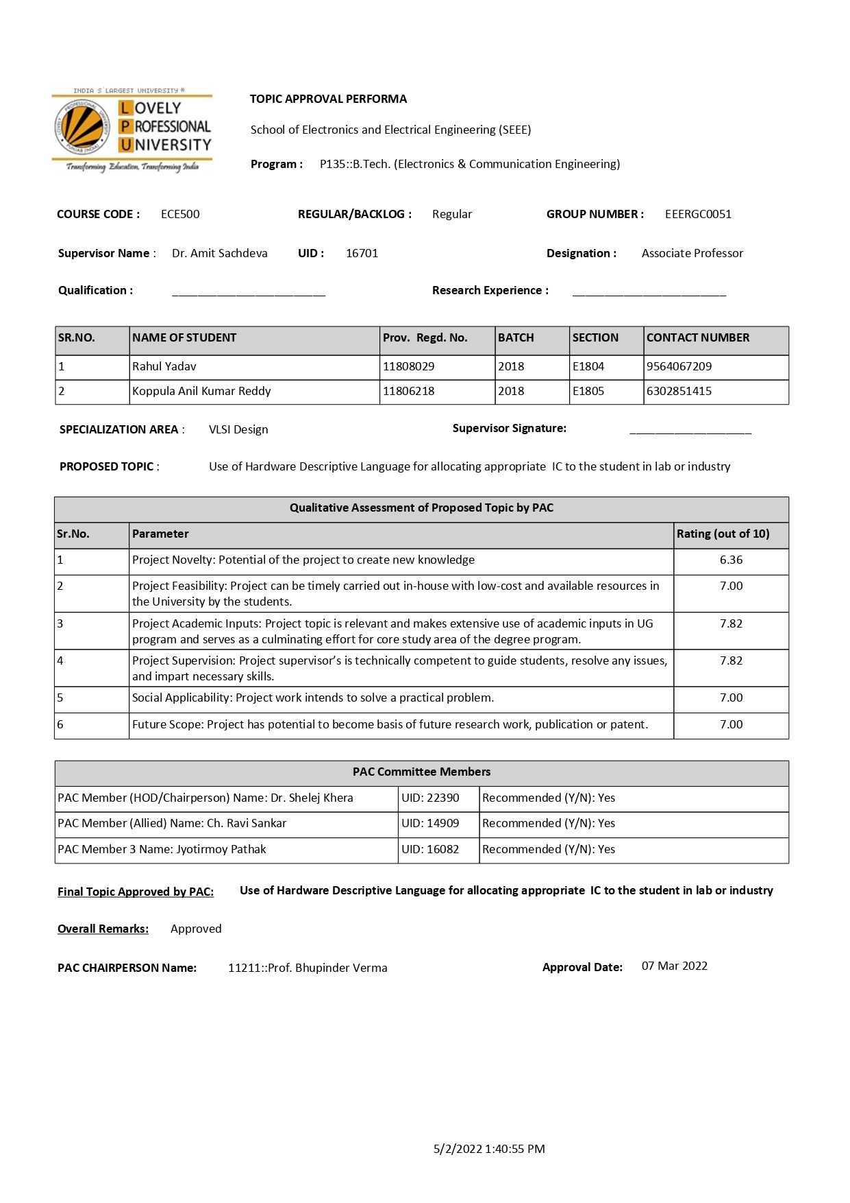

School of Electronics & Electrical Engineering Lovely Professional University
Phagwara-144001, Punjab (India)

DECLARATION
I, student of B. Tech under the Department of School of ELECTRONICS AND COMMUNICATION ENGINEERING, hereby declare that all the information furnished in this capstone project report is genuine based on my own intensive work.

This report, to the best of my knowledge, contains part of my work which has been submitted for the award of my degree from Lovely Professional University, Phagwara, under the guidance of Dr. Amit Sachdeva (from January to May 2022).

Rahul Yadav
(11808029)

Ref: _________ Dated :________

CERTIFICATE

This is to certify that I, Rahul Yadav (11808029) declaring statement made by me is correct to the best of my knowledge and belief. The Capstone Project Proposal based on the” Use of Hardware Descriptive Language for allocating appropriate IC to the student in lab or industry” is fit for the submission and partial fulfillment of the conditions for the award of B-Tech in Electronics and Communication Engineering (Final Year) of Lovely Professional University, Phagwara during the academic year 2018 - 2022.

Name: Dr. Amit Sachdeva
U.ID: 16701
Designation: Associate Professor

Dr.Amit Sachdeva
Signature of Faculty Mentor

ACKNOWLEDGEMENT

I highly indebted to the Faculty of L.P.U Electronics and Communication Engineering Department, who have given me all the necessary technical guidance in carrying out this Project. This is a humble effort to express sincere gratitude toward those who have guided and helped us to complete this project. A project report is a major milestone during the study period of a student. I could have faced many problems but my mentor helped us with a patient approach and positive criticism.
A warm thanks to our project-in-charge “Dr. Amit Sachdeva”, for the valuable support and constant encouragement that led to the completion of my project. He provided me with his valuable time and basic information regarding the project.
Finally, I thank all the people who directly or indirectly helped me through the course of my Project. Without the help of these people, my project report could have never been so informative and successful

Rahul Yadav
11808029

ABSTRACT

In the world today, A vending machine is a machine that dispenses a variety of things such as newspapers, beverages, snacks, and cold beverages. When a customer's credit currency or credit card is inserted, this is done. It is now more accessible and practical than the traditional manner of purchasing. It marketing is a multibillion-dollar industry in the United States, China, Japan, and a few other Asian countries, including India.
The outline of a proposed vending machine is depicted in this paper. This machine accepts both cash (money) and credit cards (credit). This report discusses the vending machine and how it works. With the help of a Mealy machine state chart, we created the vending machine. The system is depicted using the Verilog HDL dialect, which is a Hardware Description Language used to represent the computerised architecture. Aside from that, we added a few features to the machine to turn it into a development machine. The constructed model will be confirmed by identifying the appropriate experiments in a test seat. The requested vending machine model's Verilog code is created, and the recreation results are successfully checked using the Xilinx ISE 14.7i device.
Cash and credit cards are accepted at the vending machine we prepared. The card architecture will be more practical and will aid in access speed. The goal of this project is to design a proposed vending machine that accepts cash or card as inputs in any grouping, conveys the things once the required quantity has been stored, and returns the change. The client is provided an additional office in this situation. If the client desires, the saved cash can be withdrawn by squeezing a cross out catch in the middle of the transaction. In this project, I created a vending machine that uses less power and has less construction modelling than previous designs.

CONTENTS:-
ABSTRACT

INTRODUCTION 1

Background of the project 3

Objectives of the project 4

Scope of the project 6

Software used in the project 7

HISTORY 8

LITERATURE REVIEW 9

METHODOLOGY 10

Verilog HDL 11

Field Programmable Gate Arrays 12

Finite State Machine Method 13

Mealy Machine 13

Moore Machine 14

OUTCOMES 16

EXPERIMENTAL WORK 17

State Machine for Money system 17

State Machine for Snacks using Money 18

ADVANTAGES AND DISADVANTAGES 19

RESULTS AND DISCUSSION 20

Simulation Results 21

RTL view of Vending Machine 22

SUMMARY 23

CONCLUSION 24

REFERENCES 25

List of Tables and Figures:

Tables:

Table 4.1: State table for Mealy Machine

Table 4.2: State table of Moore machine

Table 5.1: Input/Output with remarks

Table 5.2: Product with prices

Figures:

Fig 1.1: A live Bait vending machine

Fig 1.2: First vending machine

Fig 1.3: Vending machine dispensing sacks

Fig 4.1: Mealy machine diagram

Fig 4.2: Moore machine diagram

Fig 4.3: Flow chart of Vending machine

Fig 5.1: Flow chart of vending machine using money

Fig 7.1: RTL view of vending machine

Fig 7.2: Detailed view of Vending Machine

CHAPTER 1

I. INTRODUCTION

Vending machines sell food such as canned soups and packaged sandwiches, as well as snacks such as potato chips, chocolate bars, and candy; hot drinks (coffee, tea, and hot chocolate); cold drinks (juice, bottled water, soft drinks, and in some cases, milk or chocolate milk); and other items such as newspapers or tickets.
When money is inserted into a vending machine, it is used to appropriate various things such as espresso, beverages, postcards, and gem dealers, among others. Vending machines are more practical and efficient than traditional methods of item acquisition. Vending machines can be found in schools, universities, train stations, and airport terminals, among other places, to sell tickets and drinks, as well as in banks to distribute tokens to customers.
A approach for planning an FSM-based vending machine is proposed in this report. The machine can be accessed with cash or a credit card. This machine also has a scratch off feature, which allows the customer to withdraw the interest and have the money returned to them. The equipment might be put to greater use in areas like schools, universities, and train stations. This type of machine saves money, time, and effort.
The vending machine can also be accessed by a card system, in which the card is verified using a card scanner or an attractive and compared to data stored in the host system. Following the confirmation, the card will require a pin number from the client, after which the item can be selected and an exchange may be feasible. For regular clients, the card architecture can be advantageous because it allows for a faster cash exchange system. Vending machines in countries such as Japan also sell platinum and gems, as well as gemologists, so the card system can be a more convenient option than cash. For more exchange measures, the card framework will be more feasible than the cash framework. The vending machine strategies are depicted in the images below. The vending machines are FPGA-based machines at their core. They're more adaptable, programmable, and re-usable. Previously, machines based on CMOS, SED, and microcontrollers were used. These CMOS and SED-based machines, on the other hand, are more drawn out than FPGA and microcontroller-based machines. In any case, in microcontroller-based machines, upgrading the configuration necessitates changing the entire construction modelling, whereas in the FPGA framework, we can just increase the number of pieces.

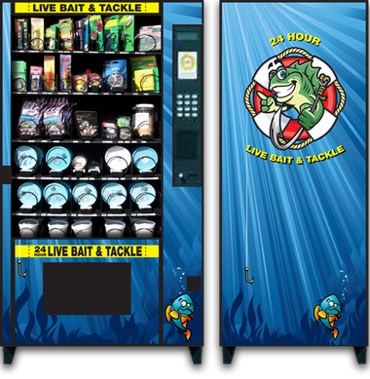
Fig 1.1 A Live Bait Vending Machine

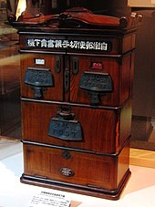

Fig 1.2 First Vending Machine

Previously, coin-operated vending machines were used to sell items like snacks, drink, and cigarettes. Vending machines provide numerous advantages, including temporal flexibility, the elimination of human labour, and quick response, hence saving time.
Already coin based Vending machines were created for offering items, for example, snacks, water and cigarettes and so on. Vending machine has such a large number of advantages, for example, adaptable in time, no need human power, and quick reaction i.e. sparing time.
To begin with, the vending machine is controlled by an administrator, so it does not require any human vitality. Vending machine manufacturers provide machines to the administrator, who selects the type of framework (i.e. instalment system) to be used. Having administrators who are working on it might also save time and effort. Second, the vending machine can be adjusted over time. It is capable of operating 24 hours a day, seven days a week. The vending machine can be used at any time, including holidays and weekends. Every year, it consumes between 2,400 and 4,500 kWh of energy. Finally, a vending machine can save time, such as during business hours. A customer does not have to waste time preparing food; instead, if there is a vending machine that sells food, simply put money in it and touch buttons to acquire food or snacks. Finally, the vending machine industry has seen significant growth over the years. A representative does not have to waste time preparing food; instead, if there is a vending machine that sells food, simply put money in it and touch buttons to acquire food or snacks. Finally, the vending machine industry has seen significant growth over the years.[1]

1. Project Background

Specialized difficulties, such as the system for instalment, significant construction, level of security, and item restriction, are the essential issues with vending machines. When we use a coin-operated vending machine, the coin acceptor frequently sticks up, causing problems with the instalment system. Using a clever card-based Vending machine, the issue with the instalment system is understood based on previous behaviours. The problem with the previous approach was that when the tank was full, no more coins could be accepted, which meant that no more purchases could be made. When coins or notes are not embedded in the correct route, they become trapped in the machine. The vending machine is unable to read the embedded coins, which may become lodged in the machine, halting future operations and necessitating repair.

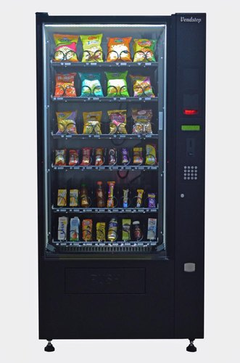

Fig 1.3 Vending Machine Dispensing Snacks

When utilizing notes as a payment option at a vending machine, the notes must be in good condition, not folded, and original. When a note is in poor condition, such as soiled and crumpled, the vending machine is unable to read it and rejects it. Finally, there are numerous complications associated with the existing mode of payment. So, in order to address these issues, I'm launching a new project that is based on both money and card-based machines and has a simpler architecture.

2. OBJECTIVES

The main objective is to create a Vending Machine Controller that accepts money or cards in any order as inputs, distributes the products when the required amount is deposited, and also returns the change. The user is given an additional feature in this case. If the customer desires, the deposited funds can be withdrawn at any time by pressing the cancel button.

Operation of Vending Machine:

Through money:-

- When a consumer inserts money into the vending machine, the money counter informs the control unit of the amount of money inserted.
- When the user selects the product he wants, the control unit activates the motor and, if the correct amount is input, the product is dispensed.
- If there is any return to be given after the product is dispensed, the machine will return to the user.
- When products are not available in the machine, the machine will request service.

Through Card:-

- When a card is introduced into the system, the card scanner or magnet reads the information on the card and compares it to the information on the host network.
- The user will be asked for a PIN code after the card has been confirmed. The user will be asked for a PIN code after the card has been confirmed.
- The card system allows for three types of transactions: product purchases, pin number changes, and cash deposits.
- The system responds appropriately to the type of transaction and is automatically updated across the network.

3. SCOPE OF THE PROJECT

Another methodology is sought in this study to plan a vending machine with auto-charging features. A methodology for planning an FSM-based vending machine is proposed in this research. Both cash and credit cards can be used to access the machine. There's also a scratch-off feature on the machine. If the client needs to withdraw his or her appeal, the money will be returned to him or her. The machine can be used in better places such as schools, train stations, airports, hotels, and food highways, among others. This type of machine saves both time and money. The degree is represented by a specific path on this vending machine.

- The vending machine that has been installed is simply a prototype and is not yet ready to be used as a commercial product.
- Snacks, milk, candy, and soft drinks, among other items, are distributed by vending machines.
- The number of goods that can be dispensed is limited.
- This vending machine accepts both prepaid payment methods (by card) and cash payments.

4. SOFTWARE USED

The code was created using the Xilinx 14.7i software. Xilinx ISE (Integrated Software Environment) is a software tool developed by Xilinx for HDL design synthesis and analysis. It allows developers to compile their designs, do timing analysis, and analyse RTL schematics.[8]

CHAPTER 2

II. HISTORY

Vending machines are extremely well-known and widely used in a variety of countries. The earliest documented instance is in the writings of Hero of Alexandria, Egypt, a first-century scholar and mathematician, around 215 B.C. His machine detected a penny and distributed water accordingly. When the coin is stored in his machine, it cleaves upon a skillet attached to a lever. The lever opened a valve, allowing water to flow out. The skillet continued to incline with the weight of the coin until it fell off, and a stabiliser crushed the lever up and killed the valve shortly after. In A.D 1076, Chinese designers unveiled another another vending machine, this time to complement a coin-operated pencil dealer. In the late 1600s, coin-operated devices were employed to distribute tobacco and other products in England. In 1867, Simeon Denham received a British patent for his stamp administering machine, which was the first fully automated vending machine.[2]
The primary advanced coin was successful. In the mid-1880s, vending machines in London were said to be dispensing post cards. Vending machines quickly became the unrivalled centrepiece of railroad stations and post offices, where they were used to purchase post cards, envelopes, and train tickets, among other things. The Thomas Adams Gum organisation created the first vending machine in the United States in 1888, providing gum on New York City train stages.[4]
Vending machines were supplied with enormous wealth in the late 1920s and early 1930s. Soda is an example of a product that was sold at the time of distribution. Espresso vending machines were invented in 1946, and merchants were invented in 1950, followed by refrigerated sandwiches.[7]
Snacks, confections, milk, cigarettes, sodas, postage stamps, cologne, baseball cards, novels, live bait, comic books, and a variety of other items may now be found in vending machines. Some greetings tech vending machines may provide hot foods such as pizza, popcorn, French fries, and burgers.
Vending machines are widely distributed and used to distribute a wide variety of commodities. The machines' transformations are produced, and shortly the machines will be utilised to sell railway tickets, with the exchange taking place by card framework. Vending machines are also used in India to distribute change and currency notes. Because of the specialised training required and the discomfort associated with using vending machines, vending machines are not widely used in some countries. Masters accept that the use of these gadgets will increase as buyer preferences and lifestyles change.

CHAPTER 3
III. LITERATURE REVIEW

The current study allows for some overlap with earlier research findings. The following are the results of these studies:
The first coin-operated vending machines that accepted post cards were introduced in London, England in the mid-1880s. The Thomas Adams Gum Company produced the first vending machine in the United States in 1888. A piece of gum is distributed by the vending machine.
In the late 1920s and early 1930s, a more noticeable cost was added into the vending machine. Cool drink and nickel-confection are two examples of items sold at the vending machine at the time. From 1946 to 1950, espresso vending machines were manufactured, followed by chilled sandwich vending machines.
Currently, a variety of items can be sold in vending machines, including clothes, milk, cigarette bundles, postal stamps, cologne, baseball cards, books, live snare, tale books, and a variety of other items. Some high-tech vending machines can serve hot foods such as pizza, popcorn, French fries, and burgers.
Roger (2008) decided that they would use a test Java customer server framework and a specific industriousness equipment limit to control a Pepsi B vending machine through the Internet. Clients with prepaid accounts can use a web software like Netscape or Internet Explorer to purchase a Pepsi A (without coins or money) from the Pepsi A machine.[10]
The designers Hong (2008) have completed a project on a remote vending machine framework based on the GSM technology. The initial priority is to analyse and consider distinct procedures by which we may comprehend remote information correspondence of the GSM system.
Following that, in 2010, Vending machines based on Single Electron Devices (SED) were introduced in VLSI innovation due to its low ultra-power usage, fast exchange rate, and high reconciliation thickness. The structure of SED is based on the unmistakable way electrons tunnel through minuscule potential barriers.[3]
The ultimate goal of this project is to implement one possible method for designing and simulating a programmed tea/espresso distribution system using electron-burrowing devices rather than traditional MOS transistors.
In a vending machine that sells sterilised water for a fee. That device measures accurately and dispenses a specific amount of water using a pressure-driven action. Every heap tube has a water apportioning outlet that is protected by a covering that is precisely organised to include the higher segment of a compartment to assist the purchaser in properly sitting the holder to be filled.
This chapter will examine the evolution of vending machines and will include information on earlier studies on vending machines that accept coins or notes as inputs.
A vending machine is a coin-operated machine that sells goods. It provides a variety of things, such as snacks, cold beverages, milk, water, drinks, and tickets. It doesn't require the services of an administrator or a labourer to operate. The vending machine provides two types of capacities.
- Selling the product
- Sell the service to the customer

The customer only sells the products given by the vending machine after inserting money. The merchandise is free at the bottom of the machine once the payment is completed. Vending machines come in a variety of shapes and sizes. Beverage vending machines, ticket vending machines, snack vending machines, and coffee vending machines are among them.
A variety of payment options are available. Vending machines nowadays have the ability to give change and accept cash or credit cards in the form of notes.

- Coin operated vending mahine
- Note operated vending machine
- Prepaid operated vending machine

A variety of studies have been conducted in order to build the advanced vending machine. The following are examples of earlier work:
- Controlling a Java-enabled Pepsi(R) vending machine via the Internet in 1999.
- Single Electron Device (SED)-based automatic tea vending system was introduced in 2007.
- This approach was used in 2011 as an efficient algorithm for vending machine implementation using an FPGA board. Because in the paper Vending Machine using Verilog HDL, FPGA-based vending machines respond quickly and consume less power than microcontroller-based vending machines.
- A new technique to designing an FSM-based vending machine with auto-billing features was proposed in April 2012.[3]
- This method incorporates elements such as cancel, product mistake, and modify.
- If the customer desires, the deposited funds can be withdrawn at any time by pressing the cancel button. Design and implementation of a vending machine based on FSM with auto-billing features in 2013. Comparison of distinct properties in modelling an FSM-based vending machine in two different approaches was published in 2014.[19]
- If the product you've chosen isn't available, you'll get a product error message.

CHAPTER 4

IV. METHODOLOGY

Previously, the vending machine was only capable of accepting cash. This sort of vending machine necessitates a greater number of gates and consumes more energy. The proposed vending machine accepts both cash and credit cards, has fewer gates, and uses less energy. The machine begins by offering the customer a choice, which is money.
Let's pretend the customer initially uses the money system. The customer can choose a product; for example, if he chooses product 1, the product will be checked for availability. Depending on the type of goods, a selection must be made, and then the availability will be checked. If the products are available, it will ask for the necessary amount of money; otherwise, it will display an error message indicating that the product is not available. The customer has two alternatives at this point: either insert the desired amount or cancel the selection. The machine will continue to check until the correct amount has been entered. The product will be distributed by the machine with the change if the correct amount is inserted.
Let's pretend the customer has access to the card system. When a card is inserted, it is first confirmed with the host network, and the consumer is then prompted for their Personal Identification Number (PIN). For the PIN number to be entered correctly, the consumer is given three chances. If the entered PIN is incorrect after three attempts, the card will be blocked. The account's information will be automatically updated on the host network. If the PIN is accurate, the machine will inquire what sort of transaction is required. This computer can handle three different sorts of transactions.

- Deposit amount.
- Changing pin.
- Purchasing a product.

If we want to deposit money into the account type 1 that has been selected, we can do so and it will be updated automatically. If we wish to buy a product of type 0, we'll complete the identical steps as in the money system, but the money will be deducted from our account. The third type, if we want to alter the PIN, we can change it and must re-enter it 13 times for confirmation, but it is successfully changed and is automatically updated through the network.

- VERILOG HDL

Description of the hardware In logic design, languages are commonly utilised. HDLs show how discrete electronic frameworks are built, modelled, and operated. For incorporated circuit designers, today's HDLs and related test systems are powerful tools. There are two types of dialects: formal and informal.

- VHDL
- Verilog HDL

Hardware description languages, such as Verilog and VHDL, differ from software programming languages in that they feature syntaxes for defining signal strength and propagation time 14. HDL is used to depict equipment using code, for example, to record reasoning capacities, to energise rationale before construction, and to integrate code into entryways and design. Verilog is a lot easier to understand than VHDL, and it's also a lot easier to utilise. Verilog HDL allows an equipment architect to draw at an abnormal state of reflection, such as at the compositional or behavioural level, as well as at lower execution levels, such as the entrance and switch levels. Clients can specify their configuration with behavioural develops in Verilog. There are two types of task administrators available in Verilog.
- Blocking Assigment(=)
- Non-Blocking Assigment(<=)

The non-blocking task enables designers to depict a state machine without having to wait for an announcement and to use short stockpiling variables. Planners might quickly assemble representations of large circuits in a usually simplified and concise structure because these ideas are part of Verilog's dialect semantics. Verilog represented a significant efficiency improvement for circuit designers who were utilising graphical schematic detainment programming and very composed programming projects to report and reproduce electronic circuits at the time of its introduction (1984).

Verilog's syntax is similar to that of the C programming language. Every one of you recalls the C programming dialect, which was widely used at the time for designing programming development. Verilog, like the C dialect, is case sensitive and features a basic pre-processor, albeit one that is less current than that of ANSI C or C++. The catchphrases (while, if/else, case) used in Verilog's control stream are identical to those used in C, and its priority of administrators is comparable to that of C. Obligated bit-widths for variable affirmations, separation of procedural squares (Verilog utilises start/end rather than wavy props), and a slew of other small differences are among the syntactic variances. Variables must be provided a positive size in Verilog.
A Verilog outline is made up of module requests. Modules represent plan order and connect with other modules via a network of stated data, yield, and bidirectional ports. A module's interior can include any combination of the following: net/variable announcements (wire, register, entire number, etc. ), simultaneous and consecutive proclamation squares, and cases of distinct modules (sub-chains of importance). Within the composition, successive articulations are placed in a start/end square and executed in a sequential order.
Sign values (4-express: "1, 0, coasting, uncertain") and signal characteristics are both included in Verilog's concept of "wire" (solid, frail, and so on.). This framework records dynamic displaying of conveyed sign lines, in which several sources drive a typical network. When a wire has many drivers, the (lucid) quality of the wire is determined by a component of the source drivers' qualities.

- Field Programmable Gate Arrays

A coordinated circuit is a Field Programmable Gate Arrays (FPGA). It consists of a two-dimensional exhibit with a variety of small processing units that can be customised. This information can be used to steer the show either horizontally or vertically inside the show. Re-steering can be affected by changing the associations between the units. For somewhat low volume gadgets, we can benefit from features such as flexibility, minimal development costs, and reduced item costs by employing this equipment. It is possible to reprogram an FPGA to start with one calculation and then move on to the next computation. It only takes a few seconds to reconfigure the system. Adaptability preferences, on the other hand, are traded off for velocities that are lower than those achieved by non-reconfigurable equipment devices like ASICs. FPGAs, on the other hand, can achieve rates that are significantly faster than programming executions. The processing units of an FPGA are sometimes referred to as Configurable Logic Blocks (CLBs). Reconfiguration modifies the elements of Configurable Logic Blocks (CLBs), as well as the associations between them. CLBs are made up of look-up tables and flip-flops. The look-up tables are set up as either a little amount of combinational logic or a small amount of RAM. A FPGA may also have RAM parts implanted that can be used as look-up tables or memory components. In any event, the use of implanted RAM may have an impact on the portability and comprehensiveness of the results obtained. RAMs also have a slower get-to time than CLBs.

- FINITE STATE MACHINE METHOD

A limited state machine (FSM), often known as a state machine, is a numerical model of counting or figuring that is used to describe both PC programmes and sequential logic circuits. It is seen as a hypothetical machine with a finite number of states. This machine goes into stand-by mode whenever it wants, and the current state is what it is in at any given time.

The behaviour of state machines can be seen in a variety of modern society devices that perform a predetermined set of activities based on a set of events with which they are shown. State machines are used to characterise neurological frameworks in science and in a fake consciousness study, as well as in semantics to characterise the punctuations of unique dialects.[10]

Every yield in a Finite State Machine is represented by an alternate arrangement of states, i.e. every yield is a state. A State Register to keep track of the machine's current state and a Next State Rationale to interpret the next state. The yield of the machine is represented by a yield register. Equipment is reduced in FSM-based machines because the complete calculation may be clarified in one methodology. There are two types of state machines:
- Mealy Machine
- Moore Machine

- Mealy Machine:- In this model, the yield is dependent on the present condition as well as the data. The condition of a Mealy machine is determined by the machine's condition. In comparison to the Moore machine, it has fewer states. Assume there are n bits; we just need n number states for these n bits.

Fig 4.1 Mealy Machine

Operation of Mealy Machine:-
The yield of the coarse state machine is regulated by the inputs and the current state of the machine from beneath the table. The yield Z will be determined by the machine's state in the preceding diagram.

Table 4.1 Mealy machine state table

Q Q* Z____
X=0 X=1 X=0 X=1
00 00 01 0 0
- 00 10 0 0
10 00 10 0 1
11 00 10 0 1

- Moore Machine:- The yield in a Moore machine is solely dependent on the present state. The condition of the JK and D flip-flops controls the status in the chart below.

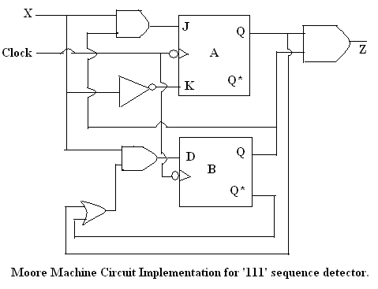
Fig 4.2 Moore machine

The state table for the Moore state machine is shown below, and it is decided solely by the machine's state.

Table 4.2Moore Machine state table

Q Q Z
X=0 X=1
00 00 01 0
01 00 10 0
10 00 11 0
11 00 11 1

The MEALY model was utilised in the project. Because the Mealy model has fewer states than the MOORE model, it is commonly employed. Mealy machines react to inputs faster because they don't have to wait for the clock. Moore machines are less dangerous to operate, and the output changes at the clock edge.

Fig 4.3 Flow chart of Vending Machine

CHAPTER 5

V. OUTCOMES

In this project, a state diagram for the proposed vending machine is created, which may vend snacks, soft drinks, milk, and candy by inserting money or a credit card. In the first part, we discuss how to obtain a product by inserting money.
A two-bit choose line is utilised for the money phase to select products such as 00, 01, 10, and 11 for snacks, soft drinks, milk, and candy, respectively. The amount line, which is 7 bits long, is used to insert the amount. When the user wants to withdraw his request, he can press the cancel button, and the money will be returned via the 7-bit output change line. The outputs are products and change, with products being one bit and change being seven bits. After each transition, this will be updated. The inputs or amount to insert money sell to pick a product, a one-bit clock signal for transitions, and a one-bit reset signal line. Table 1 lists the products along with their prices. On the positive edge of the clock signal, the machine will accept inputs and return outputs on the negative edge of the clock signal. Table 2 shows the details of the full signal, including their direction and description.

In the card phase, a one-bit insert card line is utilised to check whether the card is inserted or not, and the result is used as input. The four-bit card number line was used to input the card number. The four-bit card pin line is used to input the card pin. The two-bit input line used by the user to specify the type of transaction (00, 01, 10 for choosing product, amount deposit, and change pin, respectively) is known as transaction type. Select product is used in these three transaction types to allow the user to choose a product, such as sel=00 for snacks, sel=01 for soft drinks, sel=10 for milk, and sel=11 for candy. Amount deposit is a transaction that is used to recharge a user's card. It takes the input from the amount line, which is seven bits long and can enter up to 500 rupees. Change pin is a transaction type in which pin enter is a one-bit input line used to determine whether or not the pin is entered for the change of pin. The four-bit input line Enter pin is used to accept new pins to be modified. The one-bit input line pin reenter is utilised to conform the new pin. The four-bit input line reenter pin is used to conform the new pin. The seven-bit output line New balance is used to update the user card balance after each transaction, as well as after each product selection transaction. Snacks, soft drinks, milk, and candies are one-bit output signals similar to those used in the money phase. Amount is the same input signal used in the money phase.
It's the signal that tells the host network to update. On the positive edge of the clock signal, the machine will accept inputs and return outputs on the negative edge of the clock signal. Table 2 shows the details of the full signal, including their direction and description. The proposed vending machine was created utilising FSM modelling and Verilog HDL coding.

Table 5.1Input output with remarks

NAME WIDTH DIRECTION DESCRIPTION___

CLK 1 INPUT CLOCK SIGNAL
RESET 1 INPUT SYSTEM SIGNAL
CANCEL 1 INPUT CANCEL
SEL 2 INPUT SELECT PRODUCT
CHANGE 7 OUTPUT EXTRA EXCHANGE
SNACKS 1 OUTPUT PRODUCT
ERROR 1 OUTPUT SYSTEM ERROR
PRODUCT ERROR 1 OUTPUT NO PRODUCT
INSERT CARD 1 OUTPUT CARD INSERTED
PIN 4 INPUT PIN FROM HOST
AMOUNT 7 INPUT TOTAL MONEY
ENTER PIN 4 INPUT PIN TO CHANGE
UPDATE 1 OUTPUT UPDATE HOST NETWORK

If option 1 is selected, it indicates a money transaction. The amount, product selection, and cancel button are the inputs for money.
If the option is set to 0, the transaction will be made using a credit card. Insert card, enter pin are the inputs for cards. There are three types of transactions that can be done using a credit card.

- Select product
- Money deposit
- Change of pin

The input type is used to select any one of the above:-

Table 5.2 Product with price

S.No. Products Prices

1 Snacks 4___

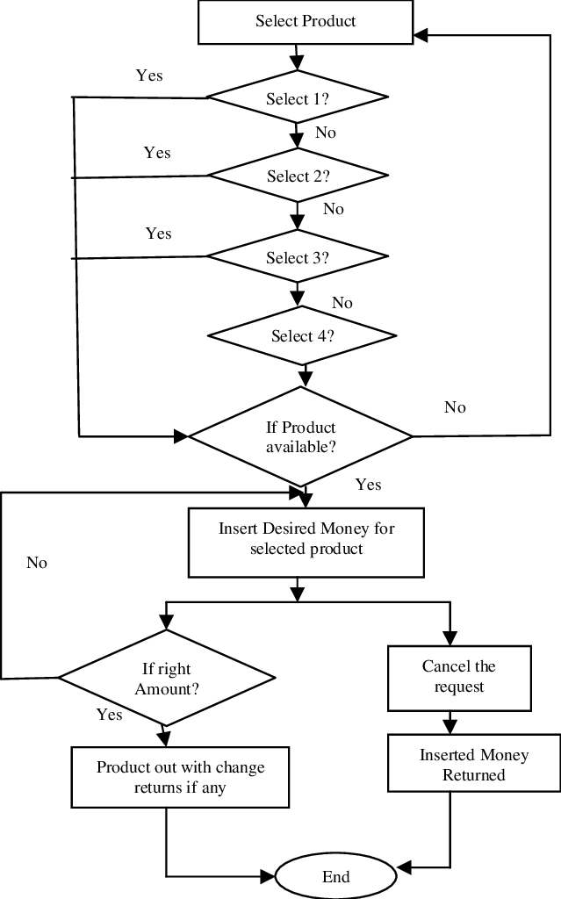

Fig 5.1 Flow chart of vending machine using money

CHAPTER 6
VII. Advantages and Disadvantages

Advantages:-
- Vending machines allow customers to purchase things at any time of day.
- In terms of the things that a vending machine can handle, there is a wide range.
- Beverages, espressos, and organic products, among other things, can be offered throughout a large territory using the machine.
- By hiring people, you can lower your overhead costs.
- It increases the owner's overall revenue, making it a win-win situation.
- If the necessity arises, the machine can simply be moved to new ranges and continue to deliver administrations as usual.

Disadvantages:-
- It can be extremely costly.
- Clients who find out a way to hack into the machine's setup to apportion items are also common in this type of fraud scenario.

CHAPTER 7
VIII. Results and Discussion

The Xilinx ISE simulator is used to simulate the state machine diagram shown in the previous chapter. Waveforms from the simulator for four different products: nibbles, soft drinks, milk, and candy. The features of the money system and card system are listed below, which include the cancel button, card recharge in the card system, pin change in the card system, and error when the product is not available.

Simulation Results

Case 1. Let's say a user wants to purchase product snacks and then cancel the selected goods in the next transaction. The simulation is depicted in the diagram below.

Description:- As indicated in the above diagram, we obtain at time-30ns for the selection of snacks, and at time-50ns for the second transition, when cancel is pressed, the machine returns the inserted money.

Case 2. Now let us take an example that user want to take a product by using card system

Description:- To pick a product utilising a card system, we have given inputs as a card, entered a pin, and then selected the type of transaction, as illustrated in the above simulation.
At time 50ns, we received an output of product candies, and the new balance, which is 240 after the transition, is updated at time-60ns. At time 120ns, the card is recharged with 100 rupees by entering the amount, and the new balance is updated as 340. Previously, the card's available balance was $250. New Pin is changed at time 190ns in the third transaction.

Case 3:- Now we're going to simulate the results of changing the pin.

Description:- Pin is altered in the following transition, as seen in the above stimulation figure, as is impacted at 70ns, i.e. changed from 1000 to 1111, and the affected same data is updated in the next clock cycle.

Case 4:- Simulation for deposit money.

Description:- The card is topped up with 100 rupees by entering the amount, and the new balance is updated to 350 in 60 seconds. Previously, the card's available balance was $250.

Fig 7.1 RTL view of Vendig Machine below

Fig 7.2 Detailed view of RTL schematic below

CHAPTER 8

XI. SUMMARY

Using Xilinx 14.7i version software, we implemented the requested vending machine, which incorporates a money-based system and a card-based system. First, we looked at all of the functions of a vending machine. The theory of finite state machines (FSM), which encompasses mealy and Moore machines, is the foundation of vending machines. However, we employed the MEALY model in the project. Because the Mealy model contains less state than the Moore model, it is employed. Mealy machines react to inputs faster because they don't have to wait for the clock. Moore machines are less dangerous to operate, and the output changes at the clock edge. Second, we created a flow plan for a money-based system and then used Xilinx software to write the code for it. We got the results.
I currently introducing a new framework known as the card-based framework. When they become natural, this will be delivered at the appropriate time. A card-based framework matches expectations, just as an ATM (automated teller machine) has a variety of options for exchanging currency, such as storing cash, withdrawing funds, exchanging cash, changing pins, checking parity, and so on. However, under this card framework, we have options such as storing cash, recharging your card, and changing your pin. As we introduce new frameworks in our lives, we are confronted with a diverse world, thus we have created a hybrid of both card and cash-based frameworks.
People nowadays rely more on the card system than the money system. It enables them to have a more secure and convenient transaction in which they can put their trust, as well as the feeling of carrying less money in their wallets. This is the primary reason for implementing both systems in this project.
Another feature has been added to this smart vending machine. The new option is a cancel button, which is not commonly found in vending machines nowadays. The cancel button is used when a person puts money into a vending machine but does not want to buy any of the other things that are kept in the vending machine. When the cancel button is hit, the money from the vending machine is returned.

CONCLUSION

When I realised that I had finally created a code that could be used to create a user-friendly vending machine that accepts both cash and credit cards as inputs, we were ecstatic. This code can give the user a range of options as well as return the money he or she owes. The Xilinx ISE 14.7i tool was used to correctly verify this Verilog code, and the necessary results were achieved. The designed model operates at a maximum frequency of 158.657 MHz, and the optimal area, power, and delay statistics are tabulated and analysed in detail.

REFERENCES

- "Design and implementation of an automatic beverages vending machine and performance evaluation using Xilinx ISE and Cadence," Proceedings of the 4th International IEEE Conference, 2013. Krishna, V.V.S.V.
- Third Edition of J. Bhaskar's "VHDL introduction."
- "Finite State Machine-based Vending Machine Controller with Auto-Billing Features," International Journal of VLSI Design & Communication Systems (VLSICS), Vol.3, No.2, April 2012. Ana Monga and Balwinder Singh.
- A. Dunlop and B. Kernighan, "A procedure for placing standard cell VLSI circuits," IEEE Trans. on Computer-Aided Design of Integrated Circuits and Systems, pp. 92–98, 1985..
- Encounter Design Flow Guide and Tutorial, Cadence, May 2010, Product Version 9.1.
- Wiley-IEEE Press, 2007. Steve Kilts, "Advanced FPGA Design: Architecture, Implementation, and Optimization."
- "Chips move vertical," IEEE Spectrum, pp. 43–47, 2004. J. Baliga
- Xilinx Inc., Spartan 3 Data Sheet: http://www.xilinx.com.
- Second Edition of Bhaskar's "VHDL Primer."
- "FSM-based Digital Design with Verilog HDL," by Peter Minns and Ian Elliott, John Wiley & Sons Ltd, 2008.
- "Passenger Requirements of a Public Transport Ticketing System," Proceedings of the 8th International IEEE Conference on Intelligent Transportation Systems, Vienna, Austria, pp. 32-37.
- P. Smith (1997) “Automatic Hot-food Vending machine,” Trends in Food Science & Technology October 1997, Vol. 81, and pp. 349.
- Replication of one-hot code using Verilog HDL,” Global Jouranl of Advanced Engineering Technologies, Vol.2, Issue-3, 2013.
- R. Kiran Kumar, “FSM Based Design on the Abishek Luthra, “Design and Implementation of Vending Machine using Verilog HDL on FPGA,” International Journal of Innovative Research in Science, Engineering and Technology, Vol.4, Issue-11, November, 2015.
- P. Pradeepa, T. Sudhalavanya, K. Suganthi, N. Suganthi, M.Menagadevi, Suganthi, et. al., “Design and Implementation of Vending Machine using Verilog HDL,” International Journal of Advanced Engineering Technology.
- Ashwag Alrehily, Ruquiah Fallatah, Vijey Thayananthan, “Design of Vending Machine using Finite State Machine and Visual Automata Simulator,” International Journal of Computer Applications, Vol.115, No.18, April, 2015.
- B. Jyothi, I. Sarah, A. Srinivas, “Implementation of FPGA based Smart Vending Machine,” International Journal of Engineering Research and Applications, National Conference on Engineering Developments, Advances and Trends, January, 2015.
- Chexel D. Augustin, Sarah Grace P. De Castro, Paul Jonathan B. Dimaano, Sarah Dyan S. Garraton, Rionel Belen Caldo, “Password Protected Vending Machine with Moore Finite State Machines using Verilog,” Laguana Journal of Engineering and Computer Sciences, Vol.3, No.2, March 2016.
- Ritika Kalihari, Toran Verma, Alka Jaiswal, “Concept of Automated Machine using Mealy,” International Journal of Computer Applications Technology and Research, Vol.2, Issue-3, pp.335-339, 2013.
- Muhammad Ali Qureshi, Abdul Aziz, Hafiz Faiz Rasool, Muhammad Ibrahim, Usman Ghani, Hasnain Abbas, “Design and Implementation of Vending Machine using Verilog HDL,” 2nd International Conference on Networking and Information Technology, IPCSIT, Vol.7, 2011.

